Exp. 8. Simulation of VI Characteristics of FINFET, CNTFET and GFET using Nano Hub

- FINFET
Output: The output Drain current Performance Vs Gate supply voltage of FinFET device
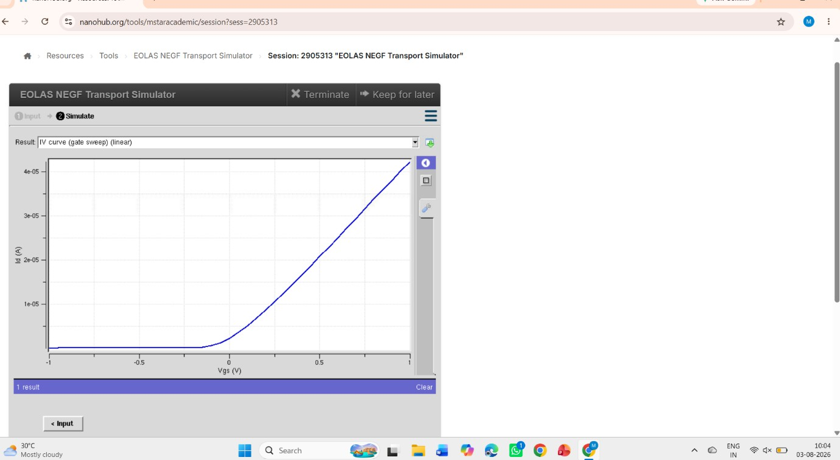
Outcome: The drain current (Id) increases rapidly with increasing gate voltage (Vgs), demonstrating effective gate-controlled switching behavior.

Case Study 1: Simulate & obtain the current spectrum characteristics for the last bias point of FinFET . Analyze the performance for different Oxide layer thicknesses

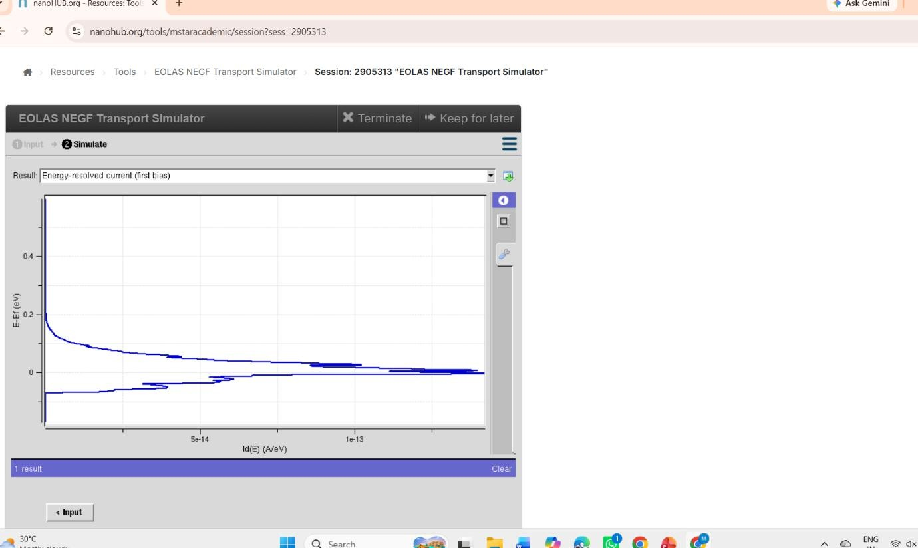
Outcome: The energy-resolved current is highest near the Fermi level and decreases with increasing energy, indicating carrier transport is concentrated at lower energies.

Case Study 2: Simulate & obtain the electron density per sheet characteristics of FinFET. Analyze its performance with different Gate region length

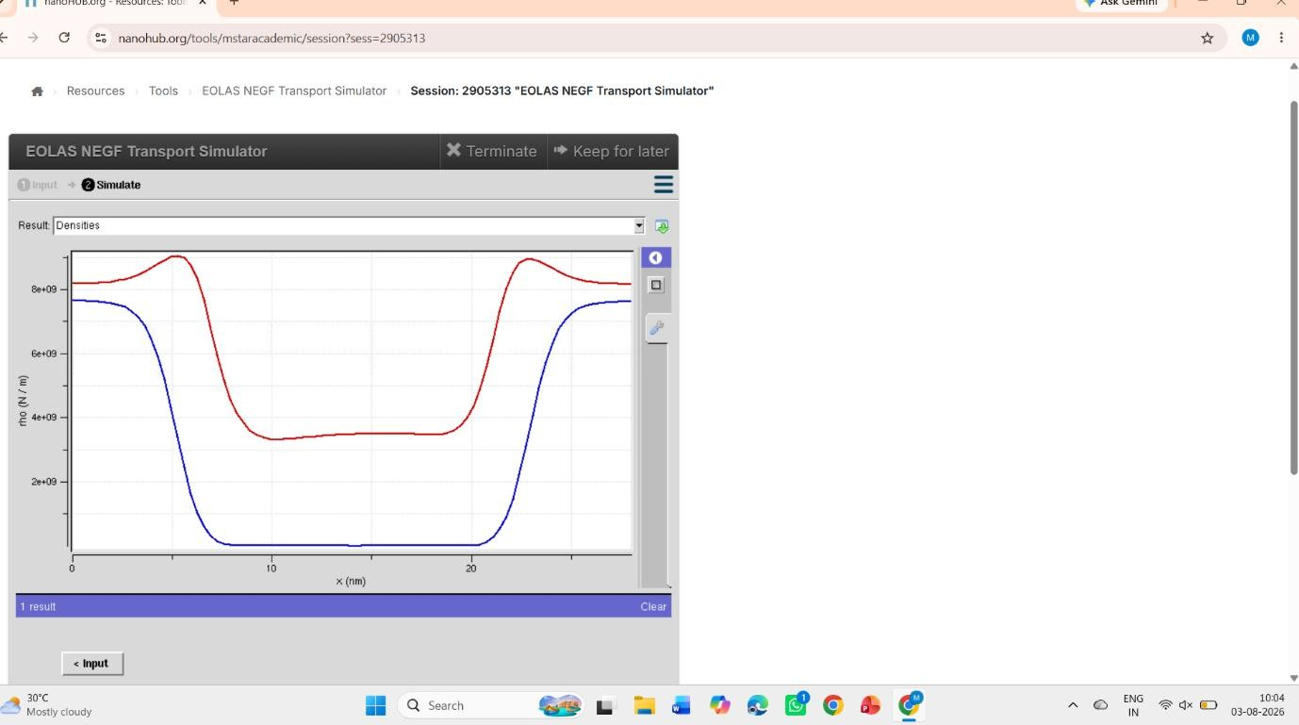

Outcome: The electron and hole densities vary across the device, showing carrier accumulation near the contacts and reduced density in the channel

CNTFET
Output:
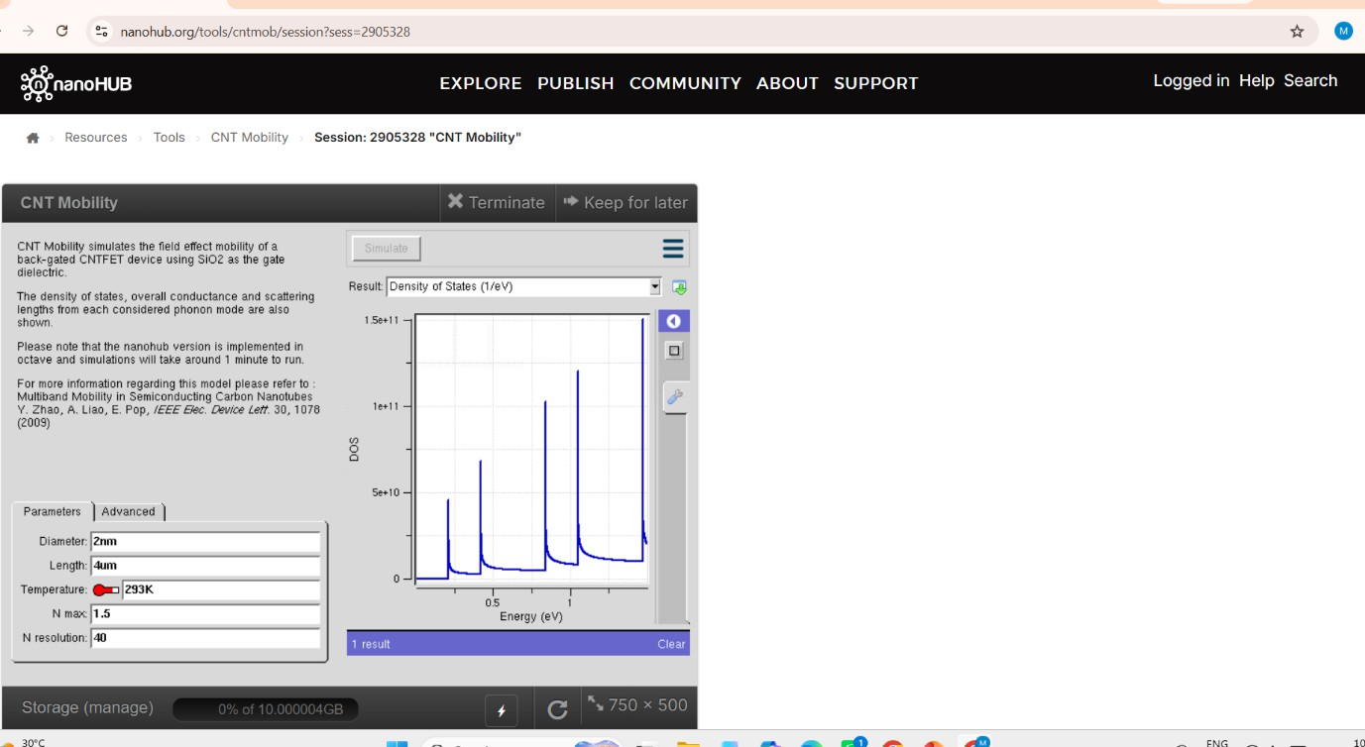
Outcome: The density of states exhibits sharp peaks with increasing energy, indicating quantized energy levels in the carbon nanotube.
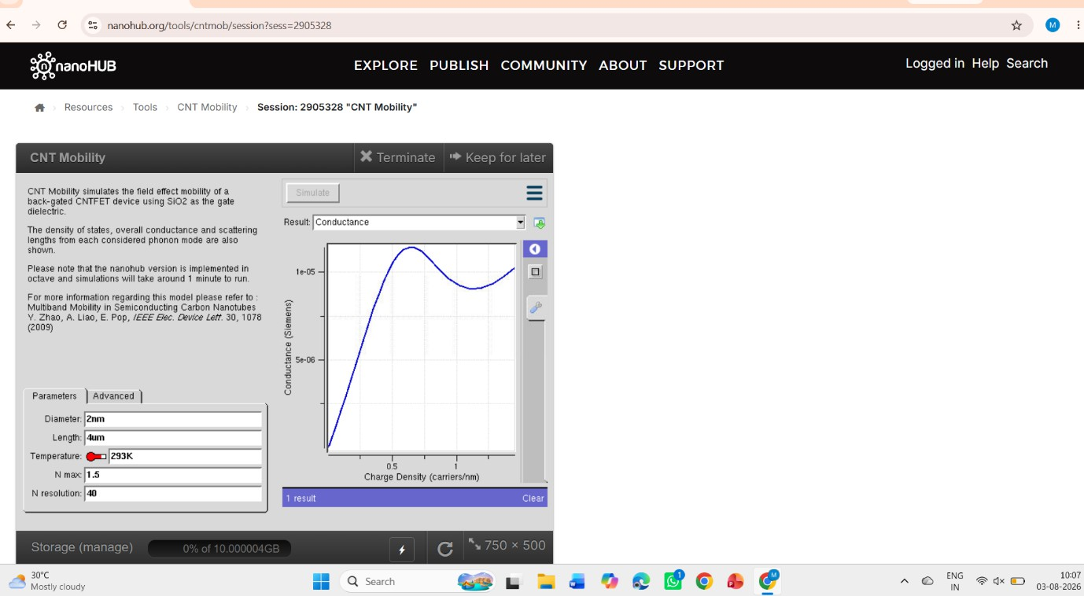
Outcome: The conductance increases with carrier density, showing improved electrical transport as more charge carriers are available.

Case study 1: Simulate & Obtain the VI characteristics of CNT-FET by varying Schottky barrier and oxide thickness
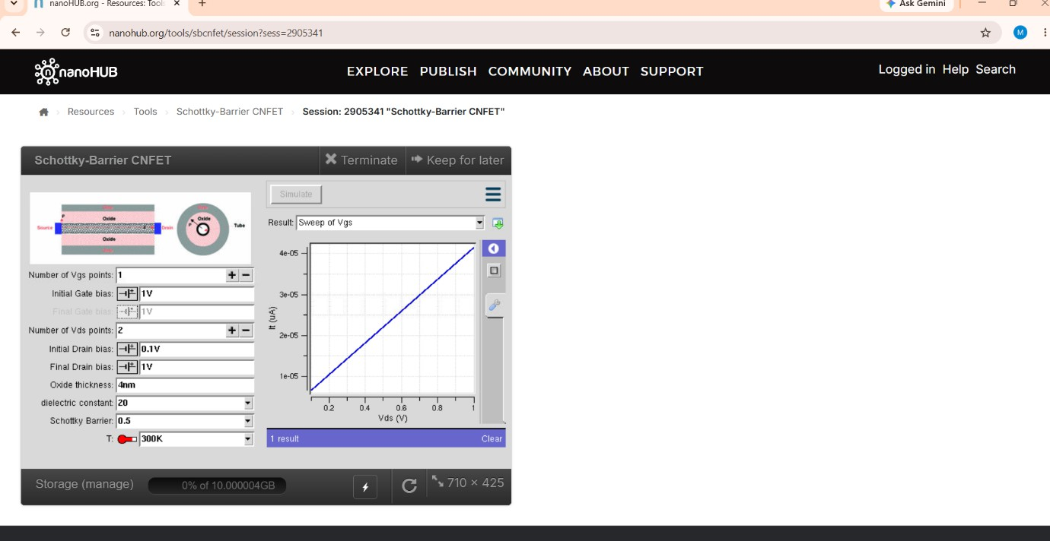
Outcome: The drain current increases nearly linearly with drain voltage, indicating stable current transport through the Schottky-barrier CNFET.

Case study 2: Simulate & Obtain the VI characteristics of CNT-FET by varying CNT diameter

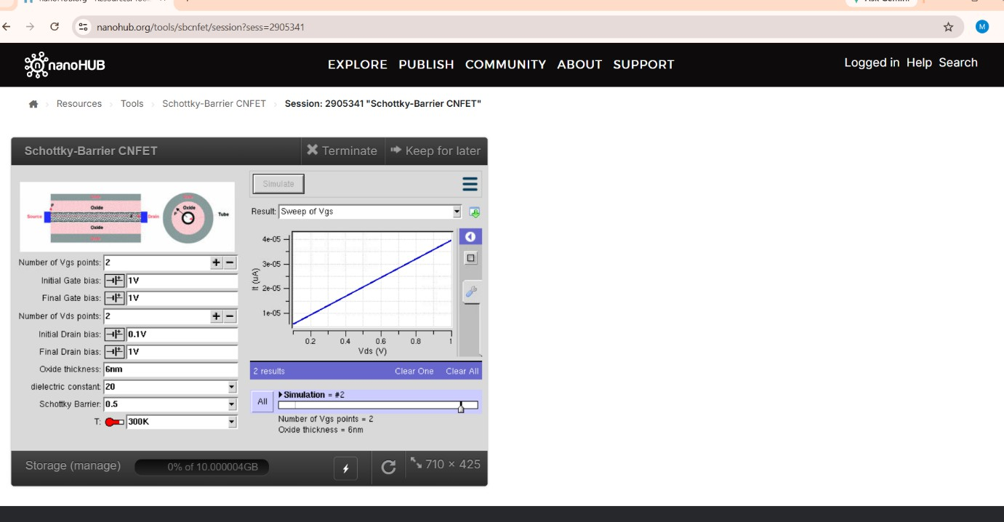
Outcome: The drain current increases with applied drain voltage under different gate bias conditions, confirming effective transistor operation.

GFET
Case Study 1:How does varying the gate voltage (Vgs) affect the drain current (Ids) in a GFET?
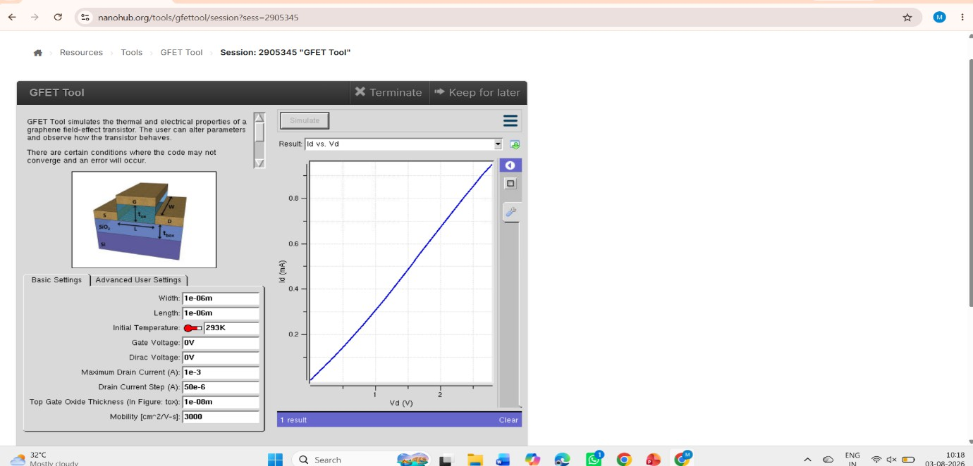
Outcome: The drain current (Id) increases almost linearly with drain voltage (Vd), indicating good current conduction in the GFET.

Case Study 2: What factors determine the maximum drain current (Ids,max ) in a Graphene Field Effect Transistor (GFET)
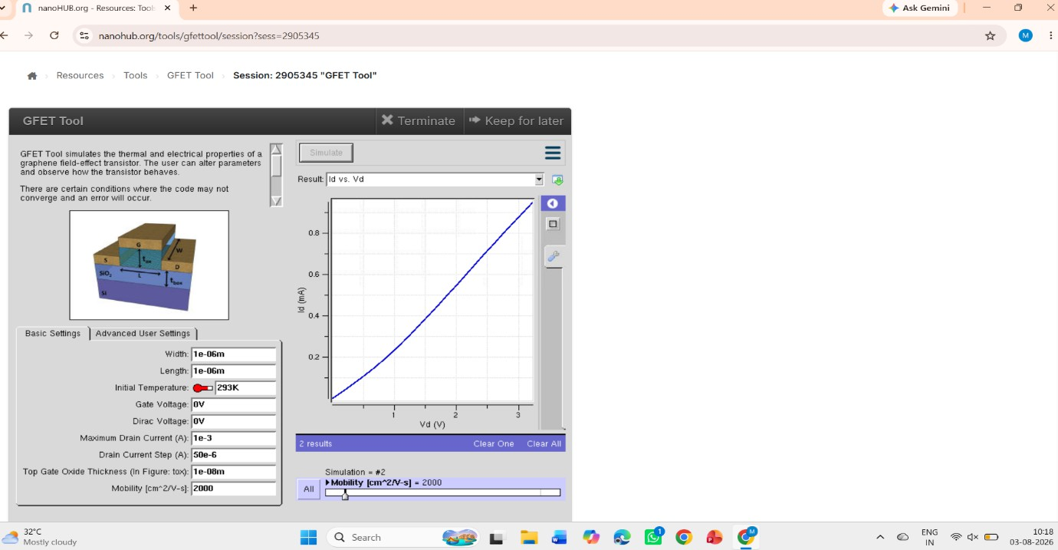
The simulated VI curves show a relatively high drain current (Ids) for a given gate-source voltage (Vgs ), demonstrating efficient carrier transport in the graphene channel

Exp. 9. Simulation of Tunneling Magnetoresistance (TMR) by Varying Barrier Height using Nano HUB
Case Study 1: Characteristics of TMR with barrier height of 0.85Ev
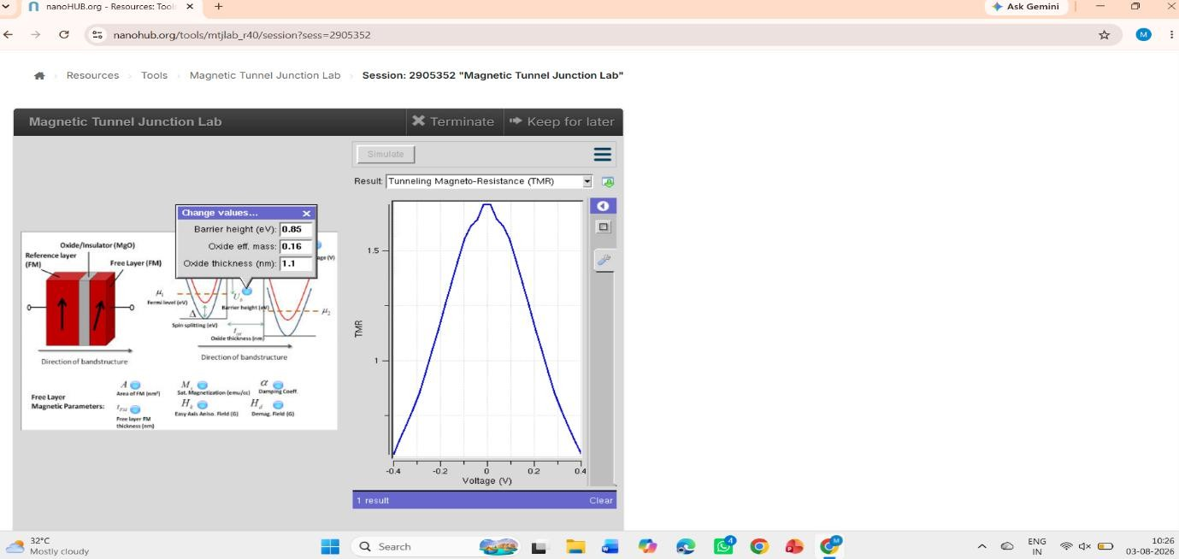
Output : TMR vs Voltage (Barrier Height = 0.85 eV):
"The TMR reaches its maximum at 0 V and decreases symmetrically as the applied voltage increases in either direction."

Case Study 2: Characteristics of TMR with barrier height of 1.0eV
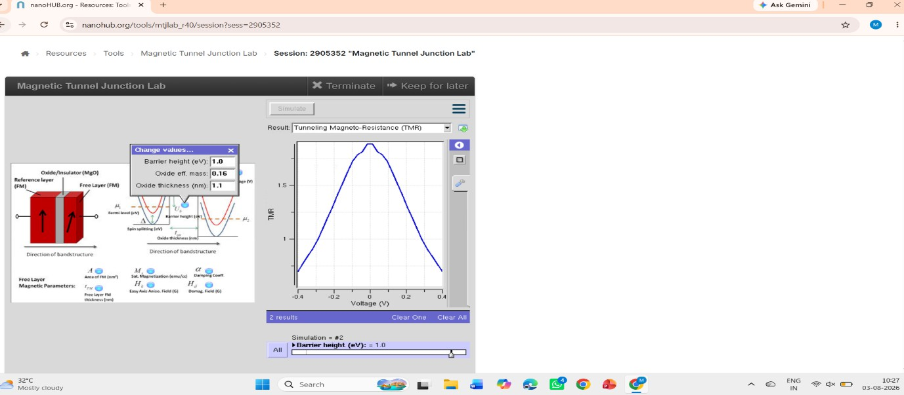
Output: TMR vs Voltage (Barrier Height = 1.0 eV):
"The TMR exhibits a peak near 0 V and decreases symmetrically with increasing positive or negative voltage, indicating optimal performance at zero bias."

Exp. 10. Biosensor and Bio-FET characteristics using NanoHub

Case Study 1: Comparative Analysis of Hybridized and Unhybridized BioFET Transfer Characteristics for Enhanced Biosensing Performance

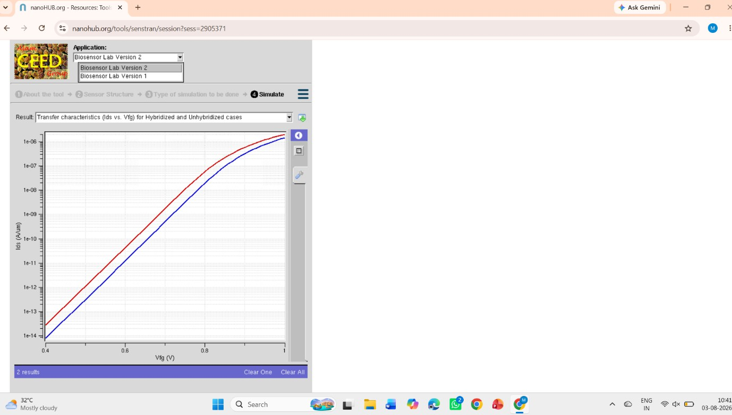
Outcome: On an industrial scale the film deposition is done by magnetron sputter deposition; on a laboratory scale molecular beam epitaxy, pulsed laser deposition and electron beam physical vapor deposition are also utilized. The junctions aren prepared by photolithography.

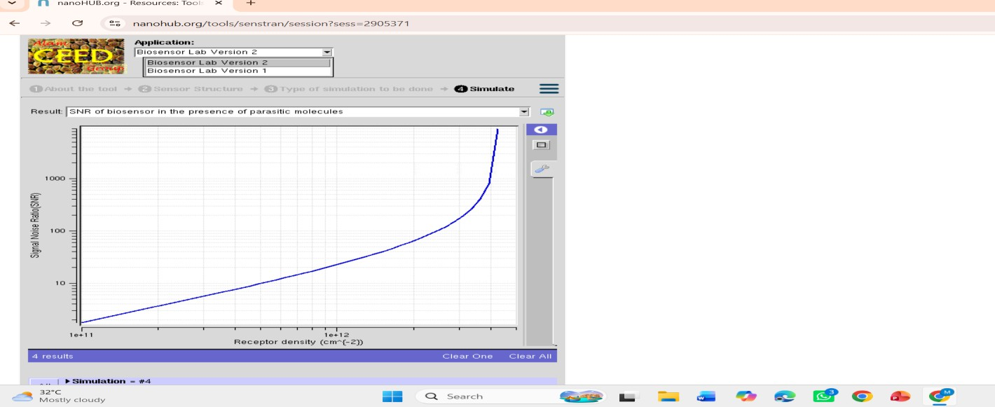
Case Study 2: Evaluation of Signal-to-Noise Ratio (SNR) Variation with Receptor Density in the Presence of Parasitic Molecules
Outcome: The simulated VI curves show a relatively high drain current (Ids) for a given gate-source

voltage (Vgs ), demonstrating efficient carrier transport in the graphene channel. High carrier mobility (2000 cm2/Vs) minimizes scattering effects, enabling rapid carrier movement and improved current conduction.

Case Study 3: Transient Analysis of Target Molecule Capture Dynamics in a BioFET-Based Biosensor
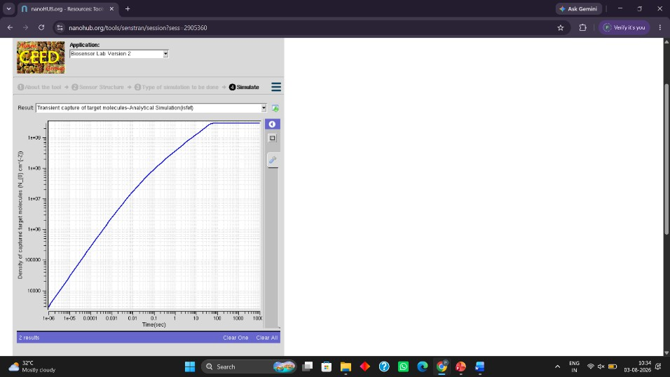

Outcome: The simulated VI curves show a relatively high drain current (Ids) for a given gate-source voltage (Vgs ), demonstrating efficient carrier transport in the graphene channel. High carrier mobility (2000 cm2/Vs) minimizes scattering effects, enabling rapid carrier movement and improved current conduction.

